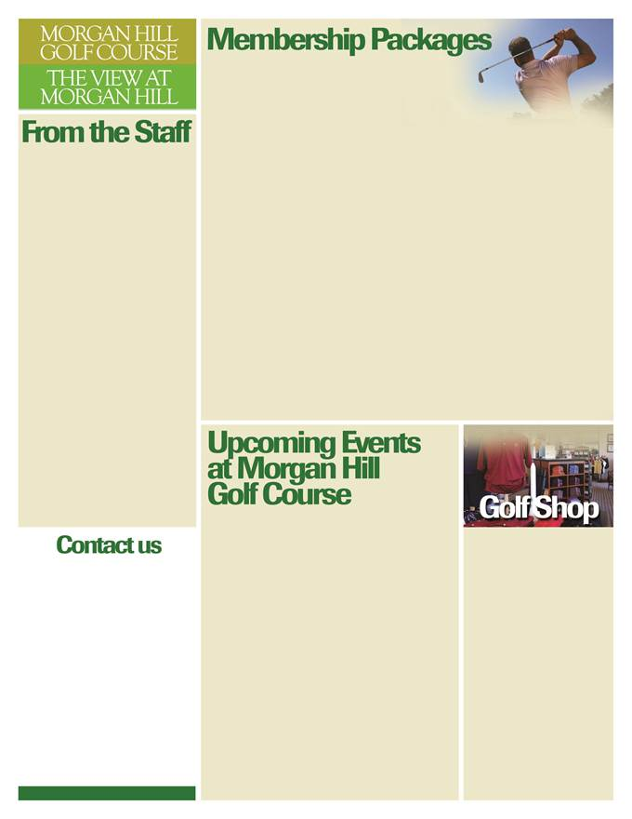

*Fall Sale!!!!*

*Golf shirts $30!*

*WINTER GEAR*

*HAS ARRIVED AT GREAT PRICING!!!*

*MIZUNO GEAR HAS ARRIVED!!!*

***JAN-FEB-MARCH***

Friday nights now music night!!  
See attached schedule

February book your Valentine’s day dinner early….  
March 26th Beer fest 12-6pm sponsored by Bud Light and Allentown beer. Book your tee time for this great event!

2015 WHAT A SEASON!

Under new ownership, great rates, golf course improvements, new restaurant “The View at Morgan Hill” What a very successful season and we thank everyone for making this a great year!! Look for great deals on Golf, Retail, special’s from “The View” in upcoming months!!

Play some great Fall Golf!!!!

**2016 Season Pass packages**

**Individual**……$3995.00  
 with spouse…… $5,195.00  
(fees include cart.)  
Season Pass packages March 1st-Dec 31st, 2016

**Weekday**…..$2,650  
 with spouse…..$3,350

**Season Pass Holder**…..$1,000  
Season Pass Holder will pay the following fees per round…. $30 Weekday cart Fee  
$40 Weekend cart Fee

Discounted rates for residents…call for pricing

***Visit our sister Courses***

**BellaVista Golf Course**  
2901 Fagleysville Rd  
Gilbertsville, PA   
610-705-1855  
bellavistagc.com

**Mainland Golf Course**  
76 Bunton Road  
Harleysville, PA 19438  
215-256-9548  
mainlandgolf.com

***Morgan Hill Golf Course  
100 Clubhouse Drive  
Easton, PA 18042***Bob Mehnert - Food and Beverage Director Ext. 19

**Patrick Mallory** –Director of Golf Ext. 21

610-923-8480  
morganhillgc.com

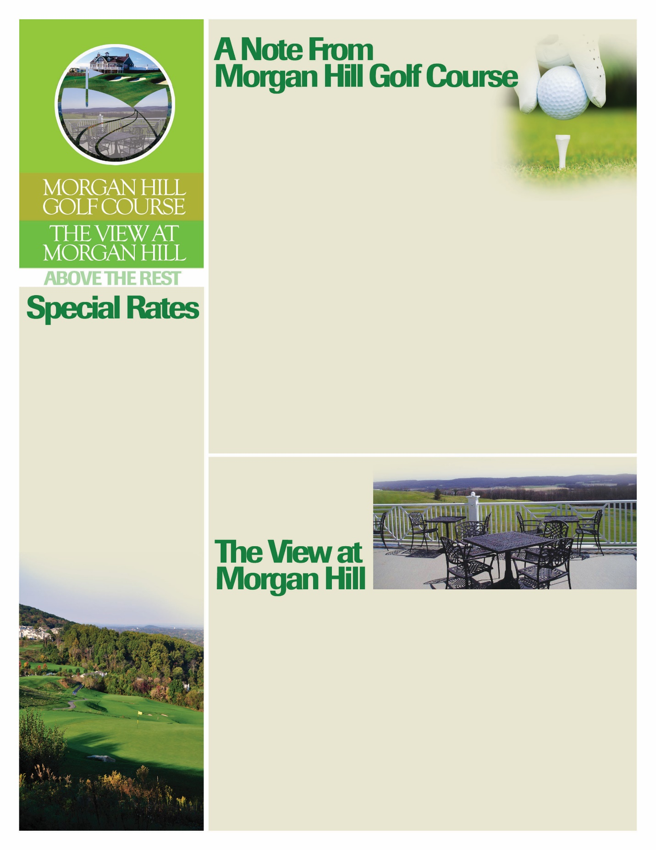

**DECEMBER – JANUARY NEWSLETTER  
morganhillgc.com**

**OUR AWESOME MUSIC LINE-UP for JAN – FEB**

JANUARY 15TH ROBERT MATARAZZO  
JANUARY 29TH TOWER SUITE  
FEBRUARY 19TH ROBERT MATARAZZO   
FEBRUARY 26TH TOWER SUITE

WINTER RATES 2015 STARTING December 1st

MON-FRI 8AM – 12PM  
$35….AFTER 12 $30  
SAT/SUN 8AM – 12PM $40….12PM – 2PM $30  
AFTER 2PM $25.00

Morganhillgc.com

610-923-8480 ext. 21

**MONDAY NIGHT** – NFL AND SOME GREAT SPECIALS!!!  
**TUESDAY PRIME RIB NIGHT** $15.00 (INCLUDES SIDE SALAD AND BAKED POTATO)   
**WEDNESDAY NIGHTS** 6-9PM – LIVE MUSIC!  
**THURSDAY NIGHT** – SEAFOOD NIGHT!!

**FRI-SAT-SUN** – GREAT DINNER SPECIALS!! VISIT THE VIEW AT MORGAN HILL FACEBOOK PAGE FOR SPECIALS….OR CALL THE VIEW!!  
**LIVE MUSIC NOW ON FRIDAYS!!! 7-10PM**

**MARK YOUR CALENDAR FOR MARCH 26TH BEER FEST!  
SPONSORED BY BUD LIGHT AND ALLENTOWN BEV**